**Introduction**

A thermometer is an instrument for measuring the temperature of a system. It is mostly used for diagnosing fever, which often occurred as a sign of infection. This device can be used in three ways: orally, rectally, and axillary. It is usually portable and equipped with a convenient digital display. The unit of measurement is either in Celsius, Fahrenheit or Kelvin system.

**Method**

To build a digital thermometer, an LM34 temperature sensor, an LCD display, and an Arduino Uno were used. The sensor temperature range is from -50 to 300 F with a gain of around 10mV/F. Knowing the resolution of the ADC of the Uno and the using system voltage of 5V, the analog voltage could be calculated. This value was also used to convert Fahrenheit to Celsius scale. All information was displayed in the LCD.

**Result**

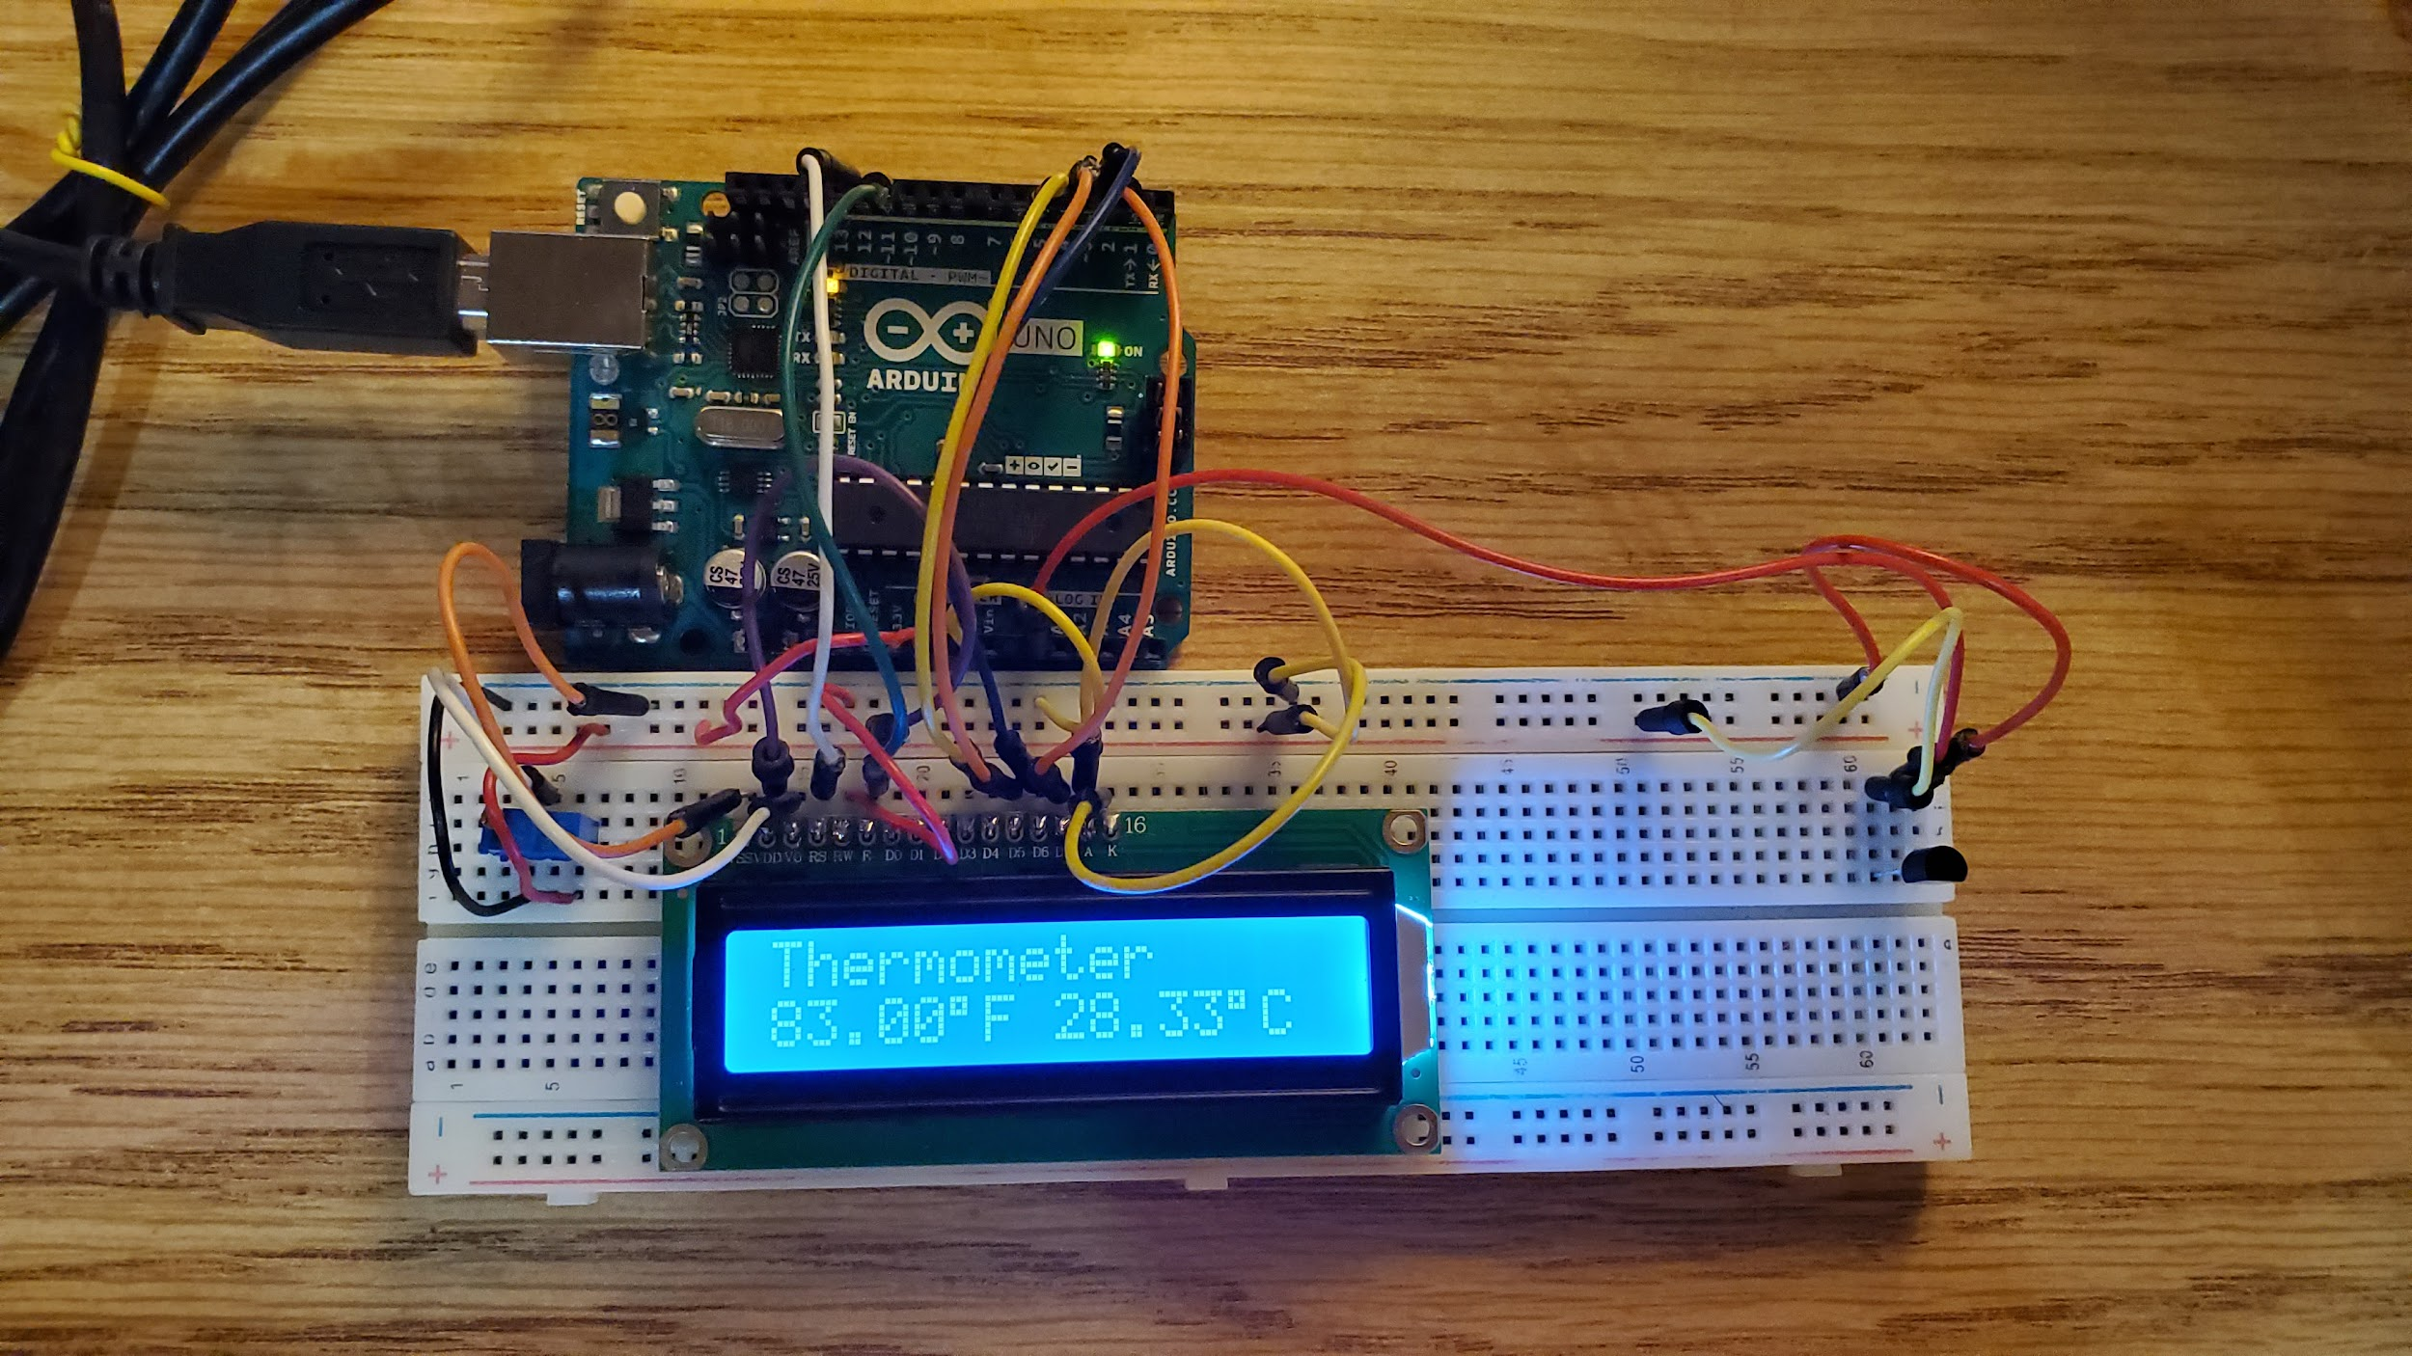

**Conclusion**

Building a digital thermometer that can display temperature in both Celsius and Fahrenheit using the LM34 was simple. The setup worked, but the sensor has a big-time constant, so it was slow in detecting changes in temperature. As a result, the value display was not very accurate. For improvement, a new sensor with better sensitivity is needed and components must be solder to establish a stable connection.

**Code**

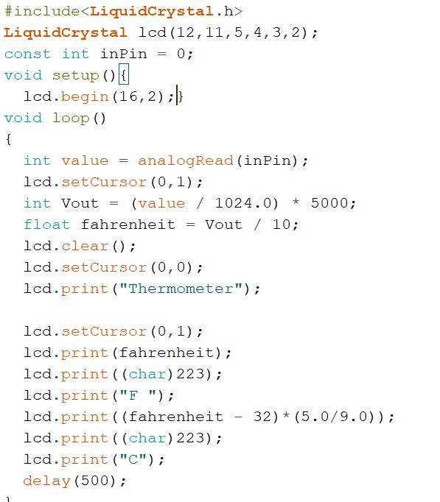

**Source**

R-B.*EmbeddedLab*,http://embedded-lab.com/blog/chipkit-project-1-digital-thermometer-using-a

n-lm34-sensor/.